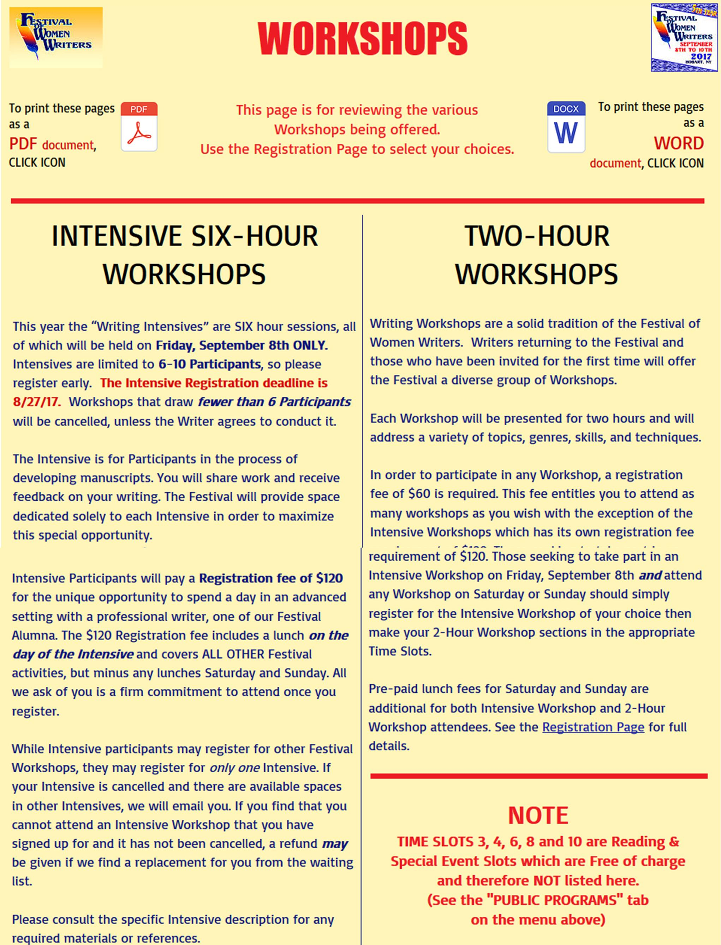
NOTE – IF THE PAGES FOLLOWING THIS PAGE APPEAR TO BE BLANK AND THERE IS A MESSAGE AT THE TOP OF THIS PAGE REFERRING TO ENABLING THE DOCUMENT FROM A PROTECTED VIEW, CLICK ON THE “ENABLE EDITING” BUTTON WITHIN THAT MESSAGE TO REVEAL THE CONCEALED DATA.



